CI/CD stands for Continuous Integration and Continuous Delivery (or Continuous Deployment). It is a set of operating principles and automated practices that software development teams use to deliver code changes more frequently, reliably, and safely.

Instead of bundling months of work into one massive, risky release, CI/CD creates an automated assembly line (a pipeline) that tests and deploys code every time a developer makes a change.

Breakdown of the Core Concepts
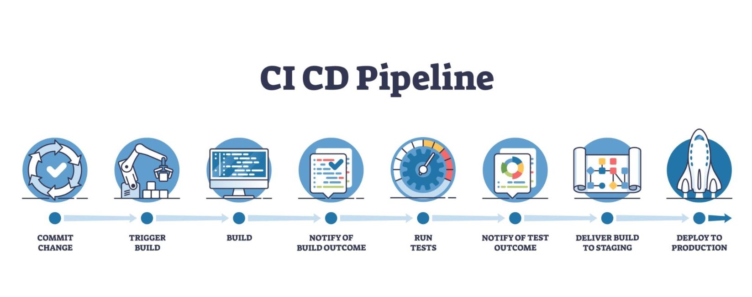

1. Continuous Integration (CI) — Automated Testing & Building
What it is: Developers frequently merge their code changes into a shared repository (e.g., GitHub, GitLab).
The Automation: Every time code is pushed, an automated system automatically pulls the code, builds the application, and runs automated tests (unit tests, integration tests).
Goal: Catch bugs early before they reach users or break other developers' code.
2. Continuous Delivery (CD) — Automated Release Readiness
What it is: Every code change that passes the CI stage is automatically built, packaged, and deployed to a staging/testing environment.
Human Step: Moving the code from staging to the actual live users (Production) requires a simple one-click manual approval by a human manager or lead engineer.
3. Continuous Deployment (CD) — 100% Automated Push to Production
What it is: Takes Continuous Delivery a step further by removing the human approval step entirely.
Zero Friction: If the automated tests pass, the change goes straight to live production users automatically within minutes.

Detailed Comparison
Feature | Continuous Delivery | Continuous Deployment
Production Gate | Manual (Requires human approval/click) | Automated (Triggers on green test suite)
Human Involvement | Developers, QA, or Product Managers decide when to ship to live users | No humans involved after code is merged
Risk Profile | Lower operational risk for strict or regulated environments | Requires extremely high confidence in automated tests
Release Cadence | On-demand (e.g., daily, weekly, or after business sign-off) | Instant (multiple releases per day as code is written)
Ideal For | Healthcare, banking, enterprise apps, or consumer apps with strict release schedules | SaaS products, web applications, highly automated startups (e.g., Netflix, Meta)

Using Docker in a CI/CD pipeline for a React application streamlines development and deployment. Because React is a client-side library, Node.js is only needed to build the static assets (JS, HTML, CSS), while a lightweight web server like NGINX is used to serve those assets in production.

A Multi-Stage Docker Build keeps production images small and secure while isolating the build environment.

1. The Multi-Stage Dockerfile
Create a file named Dockerfile at the root of your React project:

Docker file

# ==========================================
# STAGE 1: Build the React Application
# ==========================================
FROM node:20-alpine AS builder

WORKDIR /app

# Copy dependency definitions and install
COPY package*.json ./
RUN npm ci

# Copy application source and build production bundle
COPY . .
RUN npm run build

# ==========================================
# STAGE 2: Serve Static Assets with NGINX
# ==========================================
FROM nginx:alpine-slim AS runner

# Copy built static files from builder stage
COPY --from=builder /app/dist /usr/share/nginx/html

# Expose port 80 for NGINX
EXPOSE 80

CMD ["nginx", "-g", "daemon off;"]

Why Multi-Stage? Stage 1 uses Node.js (~1GB) to compile React code into static files in /dist. Stage 2 copies only those compiled static files into an NGINX image (~25MB). Your final production container drops Node.js completely, making it fast and lightweight

2. The CI/CD Pipeline Workflow

[ Push Code ] ➔ [ 1. CI Stage: Test & Build Docker Image ] ➔ [ 2. Push to Registry ] ➔ [ 3. CD Stage: Deploy to Host ]

- Source Code Check-in: A developer pushes code changes to GitHub/GitLab.
- Continuous Integration (CI):
The CI runner checks out the repository.
Runs linting and unit tests (npm test).
Builds the Docker image using the Dockerfile.
- Image Registry Push: The verified Docker image is tagged (e.g., my-react-app:v1.0.0) and pushed to a container registry like Docker Hub, GitHub Container Registry (GHCR), or AWS ECR.
- Continuous Deployment (CD):
The CD process SSHs into your server or calls a deployment webhook (e.g., AWS ECS, Kubernetes, DigitalOcean, Vercel/Render).
The host pulls the updated Docker image from the registry and restarts the container.

3. GitHub Actions Pipeline Example (.github/workflows/deploy.yml)
This configuration automates building and pushing your React Docker container whenever code hits the main branch:

name: React Docker CI/CD
on:
push:
branches: [ "main" ]
jobs:
build-and-push:
runs-on: ubuntu-latest

steps:
- name: Checkout repository
uses: actions/checkout@v4

- name: Log in to Docker Hub
uses: docker/login-action@v3
with:
username: ${{ secrets.DOCKERHUB_USERNAME }}
password: ${{ secrets.DOCKERHUB_TOKEN }}

- name: Set up Docker Buildx
uses: docker/setup-buildx-action@v3

- name: Build and Push Docker Image
uses: docker/build-push-action@v5
with:
context: .
push: true
tags: |
${{ secrets.DOCKERHUB_USERNAME }}/my-react-app:latest
${{ secrets.DOCKERHUB_USERNAME }}/my-react-app:${{ github.sha }}

deploy:
needs: build-and-push
runs-on: ubuntu-latest
steps:
- name: Deploy to Server (Example via SSH)
uses: appleboy/ssh-action@v1.0.0
with:
host: ${{ secrets.SERVER_HOST }}
username: ${{ secrets.SERVER_USER }}
key: ${{ secrets.SERVER_SSH_KEY }}
script: |
docker pull ${{ secrets.DOCKERHUB_USERNAME }}/my-react-app:latest
docker stop react-app || true
docker rm react-app || true
docker run -d --name react-app -p 80:80 ${{ secrets.DOCKERHUB_USERNAME }}/my-react-app:latest
Why Use Docker for React CI/CD?
- Consistency: Eliminates "works on my machine" issues—Node versions and NGINX configs remain identical across local, staging, and production environments.
- Environment Variables: Build-time arguments (ARG) and runtime variables can easily be injected during the build step.
- Instant Rollbacks: If a bad build makes it live, rolling back is as simple as pointing your container orchestrator back to the previous Docker image tag.

